Gas Stoichiometry, Density, Dalton’s Law

1. At STP (T = 273K and P = 1atm) 1 mole of any gas has a volume of:

PV = nRT V = nRT 1.0 mole (.0821 L-atm/mol-K) (273) V = 22.4 L
P 1 atm
But you knew that. Gas Stoichiometry is a combination of a stoichiometry problem that solves for the number of moles or the volume of a gas and then plugs into a gas law formula.
Exercise 11 Gas Stoichiometry I
A sample of nitrogen gas has a volume of 1.75 L at STP. How many moles of N₂ are present ?

7.81 x 10⁻² mol N₂

Exercise 12 Gas Stoichiometry II
Quicklime (CaO) is produced by the thermal decomposition of calcium carbonate (CaCO₃). Calculate the volume of CO₂ at STP produced from the decomposition of 152 g CaCO₃ by the reaction

CaCO₃(s) → CaO(s) + CO₂(g)

34.1 L CO₂ at STP

Exercise 13 Gas Stoichiometry III
A sample of methane gas having a volume of 2.80 L at 25ºC and 1.65 atm was mixed with a sample of oxygen gas having a volume of 35.0 L at 31ºC and 1.25 atm. The mixture was then ignited to form carbon dioxide and water. Calculate the volume of CO₂ formed at a pressure of 2.50 atm and a temperature of 125ºC.

2.47 L
2. Molar Mass of a Gas- Cat Reference to follow: 

MM = DRT D = density in g/L
P
Exercise 14 Gas Density/Molar Mass
The density of a gas was measured at 1.50 atm and 27ºC and found to be 1.95 g/L. Calculate the molar mass of the gas.

32.0 g/mol

3. Dalton’s Law of Partial Pressure- For a mixture of gases in a container the total pressure exerted is the sum of the pressures that each gas would exert if it were alone.
P_{total} = P₁ + P₂ + P₃ …
And
Ptotal = n₁RT + n₂RT + n₃RT
V V V
Therefore
N_{total} = RT
V
Exercise 15 Dalton’s Law I
Mixtures of helium and oxygen are used in scuba diving tanks to help prevent “the bends.” For a particular dive, 46 L He at 25ºC and 1.0 atm and 12 L O₂ at 25ºC and 1.0 atm were pumped into a tank with a volume of 5.0 L. Calculate the partial pressure of each gas and the total pressure in the tank at 25ºC.

P_{He} = 9.3 atm
P_{O2} = 2.4 atm
P_{TOTAL} = 11.7 atm
4. Mole Fraction and Partial Pressure
Mole Fraction – the ratio of the number of moles of a given component in a mixture to the total number of moles in the mixture.
A. Mole Fraction of C in CO₂
C = 1(12) # moles of C = 12 g X 1 mole = 1mole C X = 1 mole = .333
O = 2(16) 12 g (1 mole + 2 mole)
44 g # moles of O = 32 g X 1 mole = 2 moles O
16 g
B. With some whiz bang algebra ( check this out in the book) it can be shown that the mole fraction of each component in a mixture of ideal gases is directly related to its partial pressure.
X₁= n₁ = P₁
N_{total} P_{total}

P₁ = X₁/X P_{total}

P_{gas} =( X_{gas})(P_{total})

Exercise 16 Dalton’s Law II
The partial pressure of oxygen was observed to be 156 torr in air with a total atmospheric pressure of 743 torr. Calculate the mole fraction of O₂ present.

0.210

Exercise 17 Dalton’s Law III
The mole fraction of nitrogen in the air is 0.7808. Calculate the partial pressure of N₂ in air when the atmospheric pressure is 760. torr.

593 torr

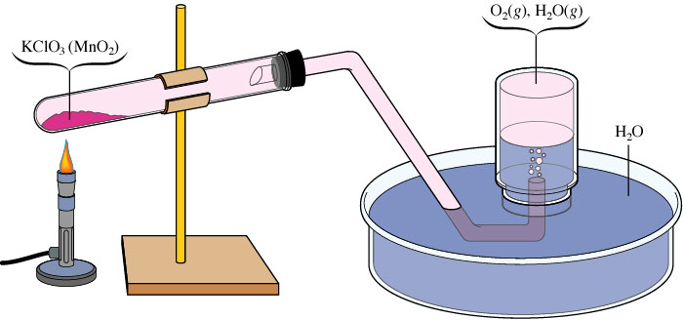
WATER DISPLACEMENT
It is common to collect a gas by water displacement which means some of the pressure is due to water vapor collected as the gas was passing through! You must correct for this. You look up the partial pressure due to water vapor by knowing the temperature.

Exercise 18 Gas Collection over Water

A sample of solid potassium chlorate (KClO₃) was heated in a test tube (see the figure above) and decomposed by the following reaction:

2 KClO₃(s) → 2 KCl(s) + 3 O₂(g)

The oxygen produced was collected by displacement of water at 22ºC at a total pressure of 754 torr. The volume of the gas collected was 0.650 L, and the vapor pressure of water at 22ºC is 21 torr. Calculate the partial pressure of O₂ in the gas collected and the mass of KClO₃ in the sample that was decomposed.

Partial pressure of O₂ = 733 torr
2.12 g KClO₃

